ENERGY FIJI LIMITED

MR245/2019
Taveuni Solar PV Power Station at Mua Research Centre and Peripheral Works on Taveuni Island, Fiji
Addendum # 3
Rescheduling of Site Visit Date:
Fiji Meteorological Services has issued a report that a Tropical Disturbance (TD04F) is heading towards the Fiji Group which may form into Tropical Cyclone in next 24 to 48 hours.
Energy Fiji Limited would like to inform all the Bidders that the Site Visit Date scheduled on 16th January 2020 at 10:00am at Mua Research Station, has now been rescheduled on the 23rd January 2020 at 10:00am at Mua Research Station
The Above rescheduled date may change subject to the aftermath of the Tropical Cyclone passing over Fiji Islands.
For any other clarification please contact: Shavneel Deo -679 9983096
Abdul Nasim – 679 9991587
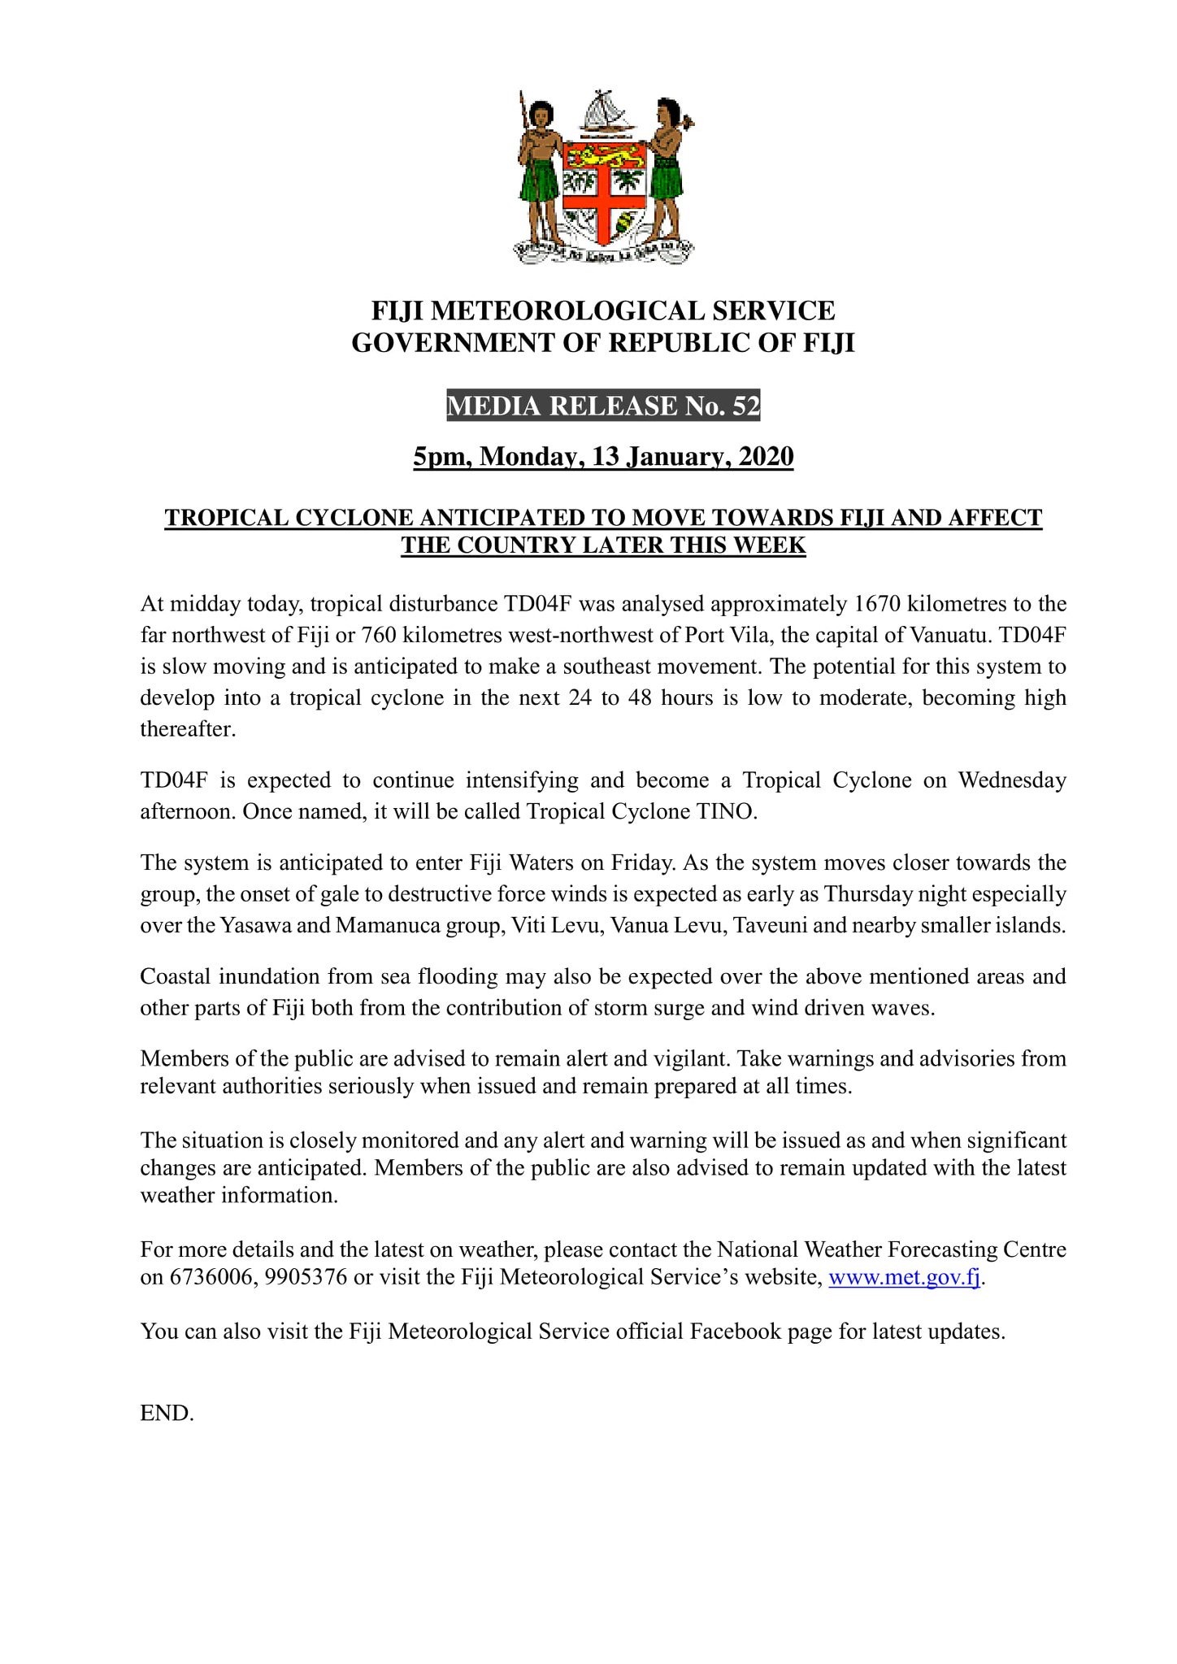
Source: http://www.met.gov.fj/current_warnings_b.php

